4.Implement histogram equalization on the given image and compare it with the original image using Open CV.

**AIM:**

To perform **Histogram Equalization** on an image using OpenCV in Python and compare it with the original image.

**PROCEDURE:**

1. Install OpenCV (if not installed):
   1. pip install opencv-python
2. Import required libraries:Use cv2 for image processing.
3. Read the image:Use cv2.imread() to load the image.
4. Convert the image to grayscale:Use cv2.cvtColor() with cv2.COLOR_BGR2GRAY.
5. Apply Histogram Equalization:Use cv2.equalizeHist().
6. Display the original and equalized images:Use cv2.imshow().
7. Wait for a key press & close windows:Use cv2.waitKey(0) and cv2.destroyAllWindows().

**PROGRAM:**

**import cv2**

**import numpy as np**

**image = cv2.imread(r"C:\Users\sr051\OneDrive\Desktop\ITA0504-CV\tree.jpg")**

**if image is None:**

**print("Error: Image not found or path is incorrect.")**

**else:**

**gray = cv2.cvtColor(image, cv2.COLOR_BGR2GRAY)**

**equalized = cv2.equalizeHist(gray)**

**comparison = np.hstack((gray, equalized))**

**cv2.imshow("Original vs Equalized", comparison)**

**cv2.waitKey(0)**

**cv2.destroyAllWindows()**

**INIPUT:**

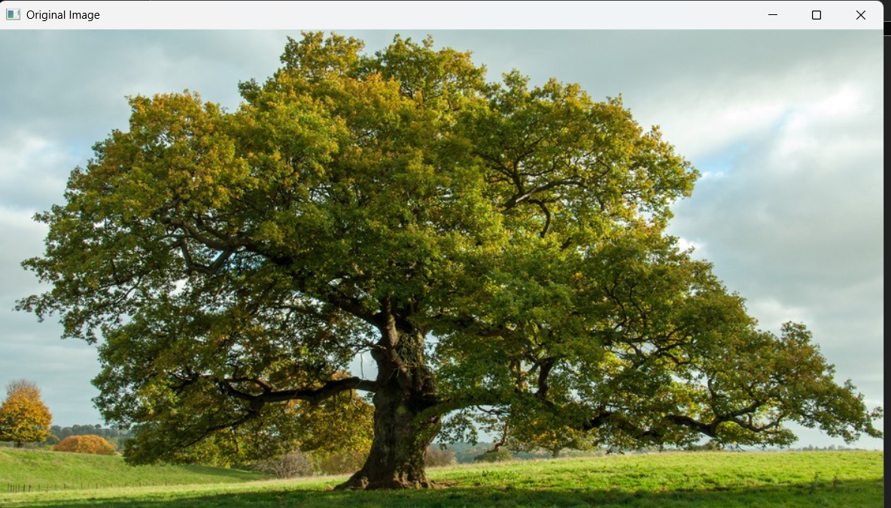

**OUTPUT:**

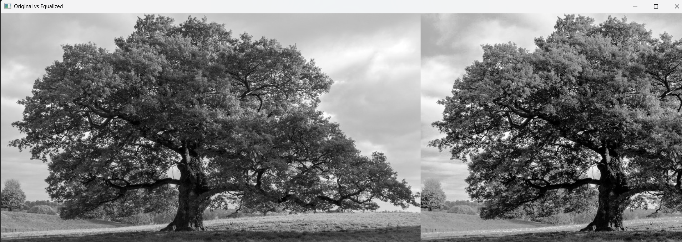

**RESULT:**

Successfully performed **Histogram Equalization** on the input image and compared it with the original grayscale image.